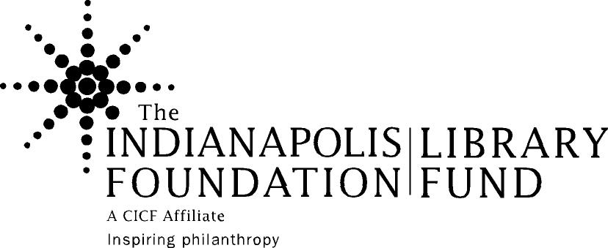

Minde Browning Professional Development Fund

Individual Application 2013

Guidelines

Background: The Indianapolis Foundation and local donors established this endowed fund in 1999 as a tribute to Minde Glenn Browning. At the time of her death in May 1999, Minde was assistant director at the Indiana University School of Law – Indianapolis Law Library, and was chair of The Indianapolis Foundation’s Library Fund Steering Committee. She was active with the Library Fund since its inception and was passionate about the development of library professionals through the Fund.

The Indianapolis Foundation, an affiliate of the Central Indiana Community Foundation (www.cicf.org), is a tax-exempt charity that develops and manages long-term assets to provide resources and leadership to the community-forever. Its three-fold mission is to inspire, encourage and bring resources to community philanthropy; make effective grants to charitable organizations; and provide leadership to address community needs. The Library Fund is a field of interest fund of The Indianapolis Foundation dedicated to benefiting designated public, academic and high school libraries in Marion County (the “Library Partners”). An anonymous donor to The Indianapolis Foundation established the fund in 1989.

The Foundation and Library Fund Steering Committee have appointed a volunteer Professional Development Committee of library staff to recommend disbursements from the fund.

Fund Purpose: The Minde Browning Professional Development Fund provides financial support for librarians and library staff to further their skills through the following areas: professional conferences and workshops, professional coursework, leadership development programs, and group programs related to libraries, media centers, etc. The fund both responds to requests from individuals and groups, and proactively offers professional development opportunities.

Applicant Eligibility: The Minde Browning Professional Development Fund is available to staff of The Indianapolis Foundation Library Fund’s Library Partner organizations. Individuals may only apply once per calendar year for support, and preference will be given to those who have not received Minde Browning Professional Development Fund Grants in the past.

Timeframe: Applications are due at the first of each month to be considered by the end of that month. Decisions will be made before the next deadline date, and applicants will be notified by mail and e-mail. Applications need to be submitted at least 60 days before attending the conference, class, etc.

Amounts: Individual grants will be awarded for no more than $1000, except as modified through proactive invitations of the committee. The committee would prefer not to fund 100% of the
costs of any particular professional development activity but understands that individual circumstances vary and different libraries have different budgeting needs.

Travel and Per Diem: Travel expenses will only be reimbursed for travel outside of Marion County. Per Diem rates will be based upon the U.S. Government travel per diem rates.

Payment: The Indianapolis Foundation will send payment to the library or institution of the person applying for a grant, or the organization, association, or school sponsoring the class or event. In exceptional cases arrangements can sometimes be made for payment to go directly to an individual. Payments will be made within three weeks of the committee’s decision.

Proposal process: Professional Development Fund proposals will be sent out to interested parties via e-mail. Individuals must submit completed proposals in the following manner:

- Send one copy via email to taras@cicf.org (Microsoft Word attachments are preferred)
- Mail or deliver a printed copy with original signatures of the applicant and his/her supervisor to:
Tara Seeley
The Indianapolis Foundation
615 N. Alabama, Suite 119
Indianapolis, IN 46204-1498

Please feel free to contact Tara Seeley at 317.634.2423 ext. 161 or taras@cicf.org for more information about the Foundation, the Library Fund or Minde Browning Professional Development Fund.

Reporting: All individuals receiving a grant will be required to submit a one-page report about their professional development opportunity. This report will be shared with peer staff of Library Partner organizations. The report form is available on the CICF Web site, and completed reports should be submitted to grantreports@cicf.org.

Minde Browning Professional Development Fund

Proposal Cover Form

You may reproduce this form on your computer if the format is followed closely.

Full name of individual requesting funds:
Title:
Organization:
Address:

Telephone number: Fax number:
E-mail:

If different from above address, mail check to:

Name of professional development opportunity:

Date(s) and location of the opportunity:

Total cost of program (registration/tuition, travel, lodging, meals):

Amount of request:

Does your organization provide any support for professional development? Yes ___ No ____
- If yes, what is the amount funded for this opportunity? __________
- If not, why not?

If this request is not funded, will you be participating in the event anyway? Yes____ No_____ and explain why yes or no:

How do you believe your participation in this opportunity will further your own professional development?

How do you believe your library’s customers will benefit from your participation in this opportunity?

ENDORSEMENT

I have carefully read the information provided for the Professional Development Fund. My supervisor has approved the submission of this proposal. If I receive funding, I agree to use the funds as granted. Following the completion of the event, I will submit a report on the opportunity attended. If funding is used for professional coursework, I agree to submit a completion record and/or grade for the course.

___________________________________
Signature of Library Staff Submitting Proposal Date

_______________________________
Supervisor Signature Date

_______________________________
Supervisor’s printed name Phone #

