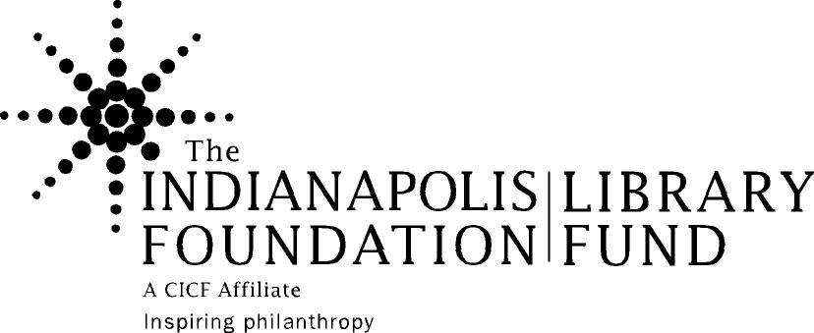
Minde Browning Professional Development Fund

Individual Application 2015

Guidelines

Background: The Indianapolis Foundation and local donors established this endowed fund in 1999 as a tribute to Minde Glenn Browning. At the time of her death in May 1999, Minde was assistant director at the Indiana University School of Law – Indianapolis Law Library, and was chair of The Indianapolis Foundation’s Library Fund Steering Committee. She was active with the Library Fund since its inception and was passionate about the development of library professionals through the Fund.

The Indianapolis Foundation, an affiliate of the Central Indiana Community Foundation (www.cicf.org), is a tax-exempt charity that develops and manages long-term assets to provide resources and leadership to the community-forever. Its three-fold mission is to inspire, encourage and bring resources to community philanthropy; make effective grants to charitable organizations; and provide leadership to address community needs. The Library Fund is a field of interest fund of The Indianapolis Foundation dedicated to benefiting designated public, academic and high school libraries in Marion County (the “Library Partners”). An anonymous donor to The Indianapolis Foundation established the fund in 1989.

The Foundation and Library Fund Steering Committee have appointed a volunteer Professional Development Committee of library staff to recommend disbursements from the fund.

Fund Purpose: The Minde Browning Professional Development Fund provides financial support for librarians and library staff to further their skills through the following areas: professional conferences and workshops, professional coursework, leadership development programs, and group programs related to libraries, media centers, etc. The fund both responds to requests from individuals and groups, and proactively offers professional development opportunities.

Applicant Eligibility: The Minde Browning Professional Development Fund is available to staff of The Indianapolis Foundation Library Fund’s Library Partner organizations. Individuals may only apply once per calendar year for support, and preference will be given to those who have not received Minde Browning Professional Development Fund Grants in the past.

Timeframe: It is preferred that applications be submitted at least 60 days before attending the conference, class, etc. The supervisor and applicant will be notified by e-mail when a decision has been made.

Amounts: Individual grants will be awarded for no more than $1,000, except as modified through proactive invitations of the committee. The committee would prefer not to fund 100% of the
costs of any particular professional development activity but understands that individual circumstances vary and different libraries have different budgeting needs.

Travel and Per Diem: Travel expenses will only be reimbursed for travel outside of Marion County. Per Diem rates will be based upon the U.S. Government travel per diem rates.

Payment: The Indianapolis Foundation will send payment to the library or institution of the person applying for a grant, or the organization, association, or school sponsoring the class or event. In exceptional cases arrangements can sometimes be made for payment to go directly to an individual. Payments will be made within three weeks of the committee’s decision.

Proposal process: Professional Development Fund proposals will be sent out to interested parties via e-mail. Individuals must submit completed proposals in the following manner:

- All applications must be signed by both the applicant librarian and the librarian’s supervisor
- Please scan signed copy and send via email to juliew@cicf.org OR
- fax signed copy to 317.637.6388 with the cover sheet indicating this is a Minde Browning fund application

Please feel free to contact Roderick Wheeler at 317.634.2423 or roderickw@cicf.org for more information about the Foundation, the Library Fund, or Minde Browning Professional Development Fund.

Reporting: All individuals receiving a grant will be required to submit a one-page report about their professional development opportunity. The report form will be sent to awardees electronically and is to be submitted to grantreports@cicf.org.
Minde Browning Professional Development Fund

Proposal Cover Form

Date:
Full name of individual requesting funds:
Title:
Organization:
Address:

Telephone number:
Fax number:
E-mail:

If different from above address, mail check to:

Name of professional development opportunity:

Date(s) and location of the opportunity:
Number of times you have participated in this opportunity:

Total cost of program (registration/tuition, travel, lodging, meals):
Registration/Tuition | $
Travel (anticipated) | $
Lodging (anticipated) | $
Meals (per diem) | $
Other costs | $
Total: | $

Amount of request:

Does your organization provide any support for professional development? Yes ___ No ____
- If yes, what is the amount funded for this opportunity? __________
- If not, why not?

If this request is not funded, will you be participating in the event anyway? Yes____ No_____ and explain why yes or no:

How do you believe your participation in this opportunity will further your own professional development?

How do you believe your library’s customers will benefit from your participation in this opportunity?

ENDORSEMENT

I have carefully read the information provided for the Professional Development Fund. My supervisor has approved the submission of this proposal. If I receive funding, I agree to use the funds as granted. Following the completion of the event, I will submit a report on the opportunity attended. If funding is used for professional coursework, I agree to submit a completion record and/or grade for the course.

___________________________________
Signature of Library Staff Submitting Proposal Date

_______________________________
Supervisor Signature Date

_______________________________
Supervisor’s printed name Phone #

Supervisor’s email: ________________________________________

