- How Do I Log In?
Go to https://cicf.smartsimple.com. If you are a new user click on the Register Here button. If you or your organization have already created a profile in the grant portal, enter your email and password and log on. If you have forgotten your password, click on the Forgot Password link and a temporary password will be emailed to you. Please note, the grant portal will automatically log you out of the system if left idle for 30 minutes.
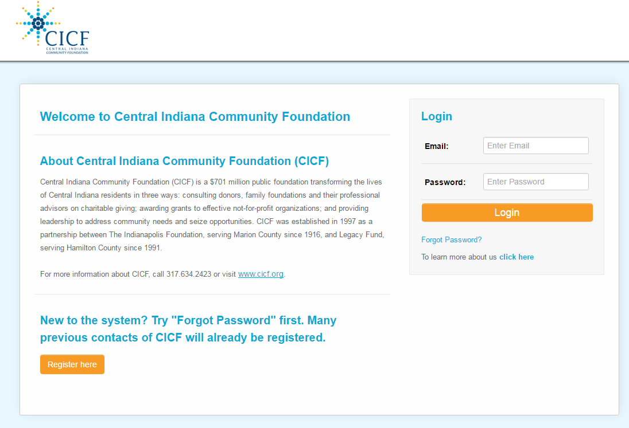
How does an application enter the system?
An applicant will set up a profile using the “forgot password” system on the login screen. Wait for the access email, then log in following the instructions in the email. IF they are a brand new org to CICF they will click on the Register Here button instead of forgot password.
Registration page: Follow the instructions!!!
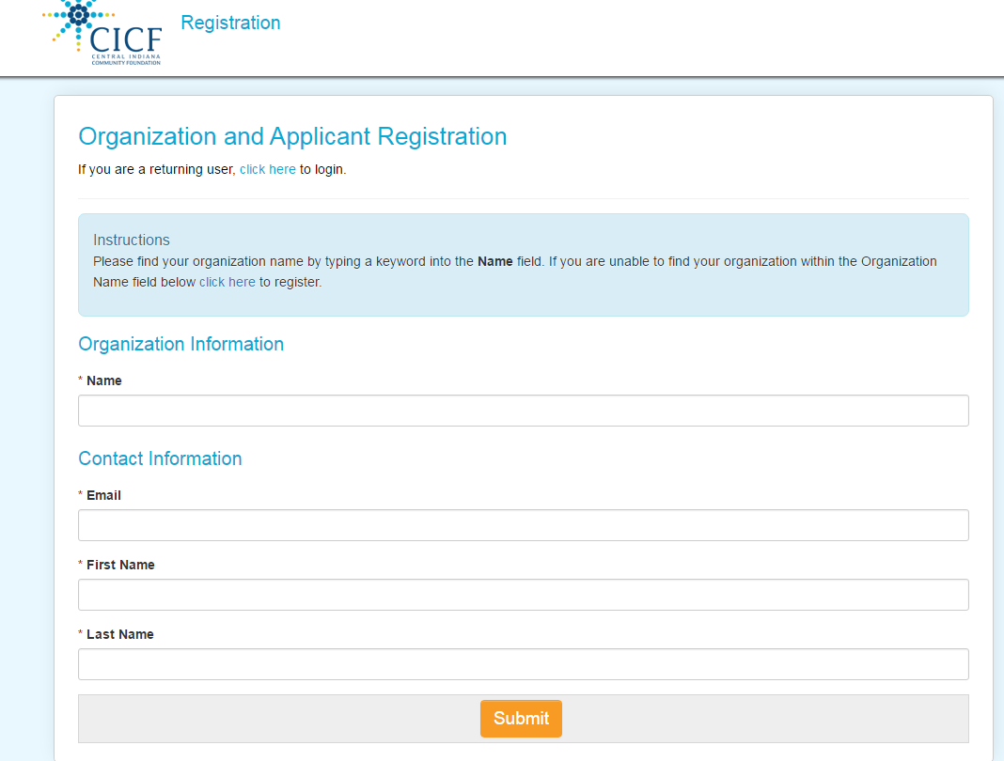

Screen shot once logged in:
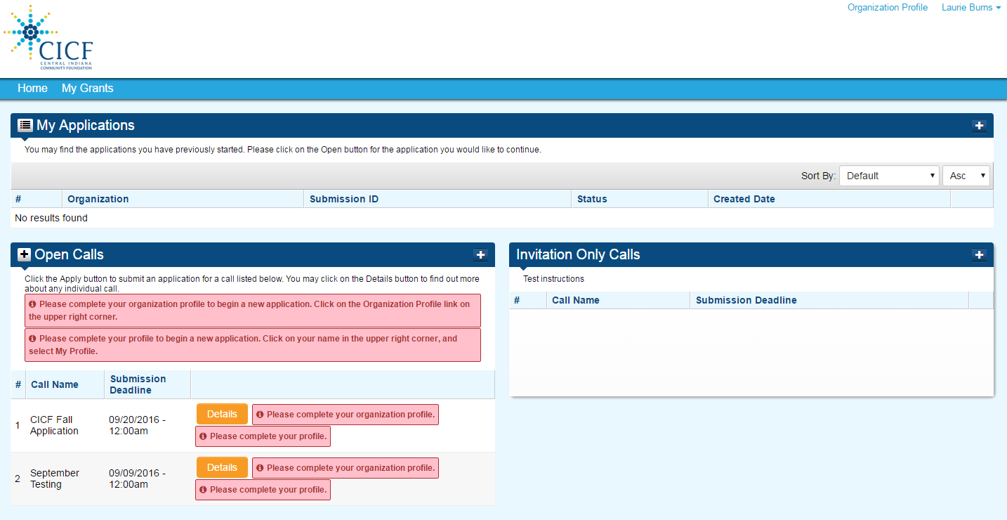

Step 1: Review, Update, & Complete Organization profile by clicking on “Organization Profile.”
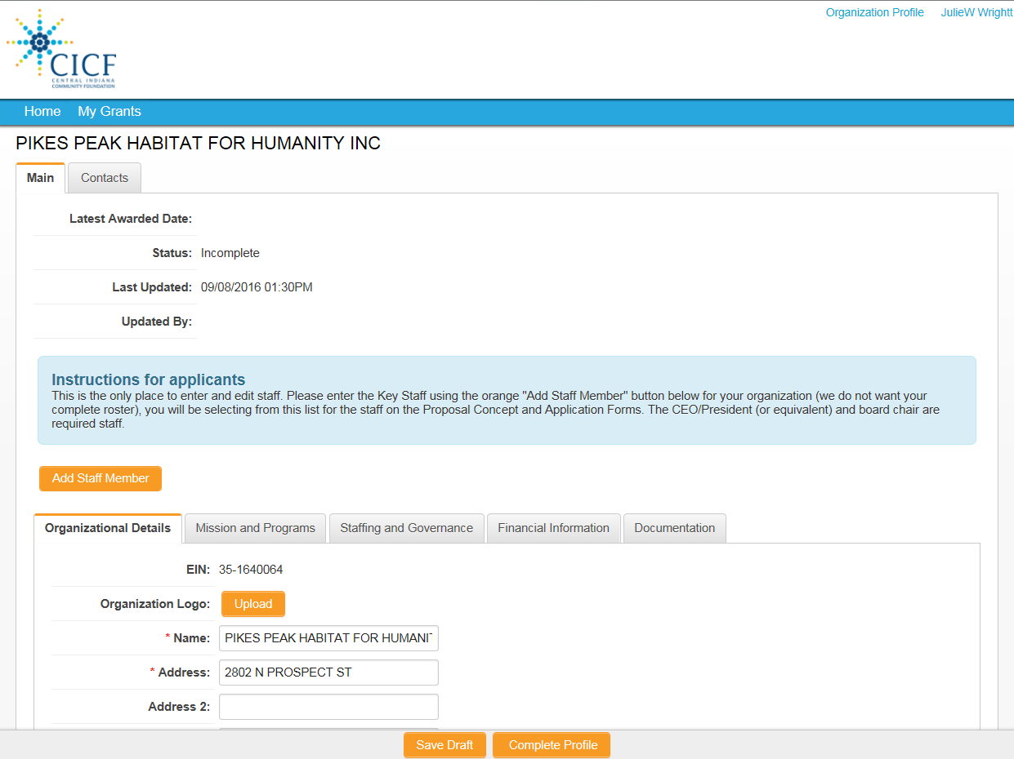

The document upload tab on the organization profile allows applicant to upload the organization related documents: 1) 990 or Financial Statement, 2) Board List, and 3) organization budget one time per year instead of with each application.

Contacts for the organization will be added using the Add Staff Members button in the middle of the page. This is the one place to add organization staff. A minimum staff requirements are 1) CEO/President (or equivalent), 2) Board Signatory. The applicant can then assign a staff member to an application.

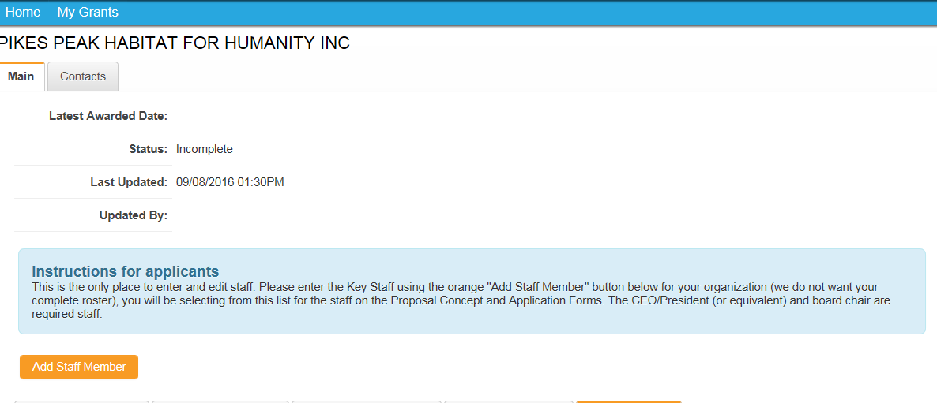

Once the profile information has been completed, use the drop down menu in the upper right to complete the individual profile. When the individual and organization profiles are complete, the home screen will show applications that are available in the “Open Call” Section. Click the Details button for information and the Apply button to start an application.
Still need help?
Please contact Julie Wright at juliew@cicf.org.

